Supervisor’s Name: Rasha



**Project Aim**:

I want to design and build an online platform for E-Learning. Make users feel that learning is an autonomous and spontaneous process, students are not interrupted by a relentless clock while researching a problem, and the goal of this system is to help students gain a deeper understanding, not to make them Studying for exams gives students ample time and freedom to follow the path of interest, guided by their own curiosity.

**Project Objectives**:

E-learning platform Functionally I think it needs:

1. User registration/login/

Users can register according to email/phone/username, etc., can have nickname, password

2. Personal homepage

Users can have their own personal profile, and the profile can modify the information of various first steps

3. Permission division (administrator/common user)

Administrators can see the course list, add, delete, modify and check courses

4. The introduction page of the course (title, content)

5. Course related training video upload function, video download function

6. The video playback function of the course (need to integrate a streaming media player, and html5 player)

7. The home page of the website displays the course, go to registration, login, personal homepage, various places

8. Some advanced functions, such as the information of the E-learning whole station course, do the knowledge graph function (analysis, knowledge graph association and visualization)

9. Recommendation system (using collaborative filtering recommendation algorithm based on offline data of other users, recommending courses that users may be interested in/should learn)

**Description**:

The current educational system divides knowledge into disciplines and further divides disciplines into separate units. There is a potential risk in this division, which creates the illusion that each point of knowledge is scattered and unrelated. This is a very serious problem, but a more fundamental problem is that the knowledge points may not be fully covered, this is because the school decides the learning progress according to the learning time of each knowledge point, not according to the mastery of each student degree to arrange the study plan. After finishing a knowledge point according to the allotted time, the teacher will quiz the students and start to move on to the next knowledge.

Now Machine Learning and Data analysis has developed and used in Internet website . With the recommendation System on E-Learning system and the knowledge graph connects all knowledge points, breaking the limitation of separate class hours and domain knowledge, I think it will make a difference.

From a practical point of view, our traditional classroom teaching model does not have sufficient conditions to provide each student with targeted review and make-up exams, nor does it allow students to get rid of rote learning methods and understand through open and creative ways Knowledge.

I've always felt that with the help of online video courses that are self-paced by students, already interactive and assisted by big data, coupled with computer feedback and the help of a team of teachers, students only need to spend 1-2 hours a day on basic courses, but they are free hours to work on individual or group innovative projects, such as writing poetry, writing computer code, making movies, building robots, painting, or conducting small experiments related to physics or mathematics

**Initial areas of research**:

Initially, I plan to build the main framework of the website(flask/bootstrap/vue/Sqlchemy),including video uploading and downloading of online courses, as well as user registration and login systems. I think this is the initial basic function.图像

Follow-up advanced features: recommendation system and knowledge graph system, I will add it later

**Expected outcomes**: A real system that is usable and practical to help review and learn related knowledge outside of the classroom. It can really help students, this is what I expected it to be.

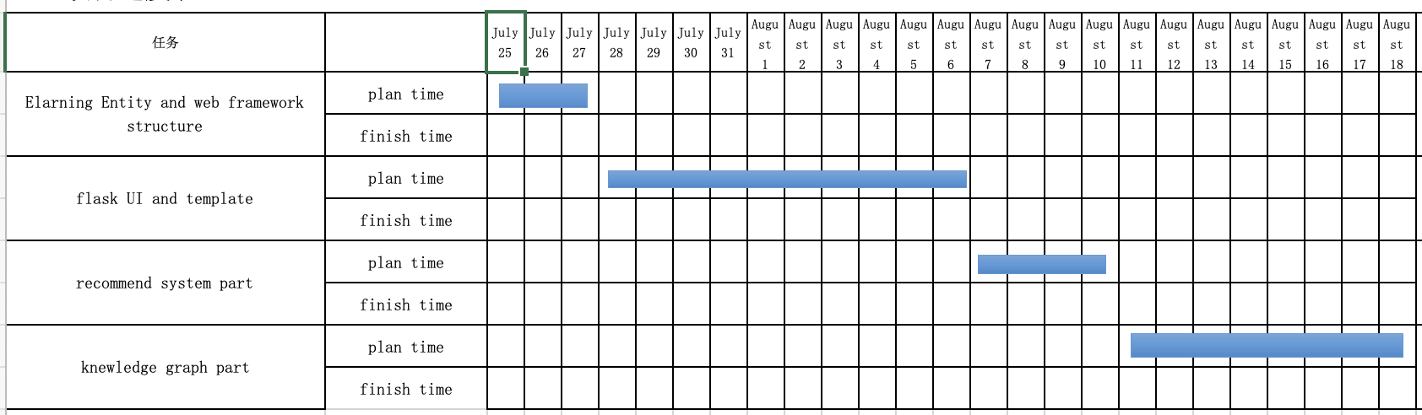**Project plan**: